Counselor’s Corner  Mrs. Kristin Hartzheim (K & 1)  https://kristineve7.wixsite.com/mysite  Dr. Missy Johnson (2nd-5th grade)  https://stilllearning.typepad.com/counselors_corner/  Our Virtual Hours: 9:00-10:30am |  | March 23-March 29th
How can We Help!  Dear Parents,  Your school counselor is here to assist in navigating through these uncertain times. We can help with connecting you to resources, parenting tips and providing counseling services. Please feel free to reach out via email. Our virtual hours are simply hours we will be readily available between 9-10:30. However, we are still available throughout the day. We will be happy to help in any way that we can. Please check out our blog for updates or additional resources.  Parents without Technological Devices: There are some local computer stores, some that repair and sell computers that are offering loaners, or a monthly payment plans on computers.https://www.spectrum.com/browse/content/spectrum-internet-assist  If you have a computer but you do not have access to internet there are several servicers that are offering free or discounted internet access https://www.wxyz.com/news/national/coronavirus/comcast-offering-internet-essentials-package-free-for-60-months-during-coronavirus-outbreak  However, if you are unable to access a technological device please inform your teacher and they will be happy to work with you for alternative learning activities. | General TIPS for Talking to Children regarding COVID-19 from the CDC  - Remain calm and reassuring.  - Make yourself available to listen and to talk.  - Avoid language that might blame others and lead to stigma.  - Pay attention to what children see or hear on television, radio, or online.  - Provide information that is honest and accurate.  - Teach children everyday actions to reduce the spread of germs.  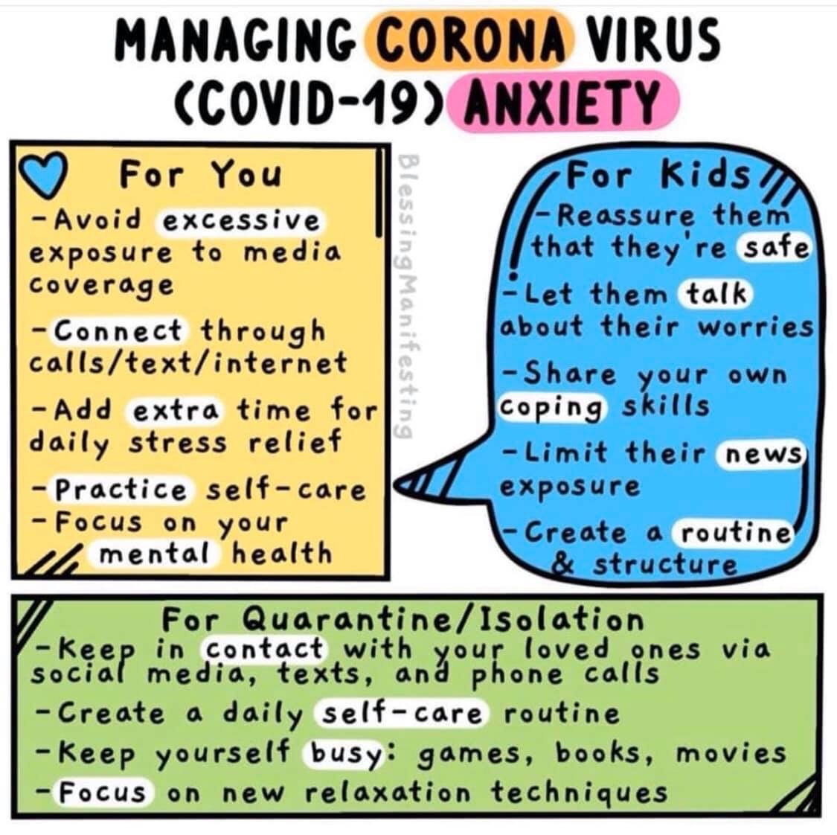  https://www.cdc.gov/coronavirus/2019-ncov/community/schools-childcare/talking-with-children.html
Counseling Core Curriculum  Please know that your Counselors miss seeing your faces and we can not wait until school resumes and we can get back to our normal routine. Parents you may not know, but we visit your child’s class biweekly which we provide Counseling Lessons that address Social Emotional Learning, Academic and Career Readiness. For extension learning here are some links for social and emotional learning.  From Mrs. Hartzhielm  (Grades K & 1)  Online Social Emotional Learning for K-1:  www.wedolisten.org  https://charactertree.com/  Resources for talking to children about the Coronavirus for K-1:  https://www.youtube.com/watch?v=ZD9KNhmOCV4  https://660919d3-b85b-43c3-a3ad-3de6a9d37099.filesusr.com/ugd/64c685_bec2d5e852fc46ed8e7d0f2396fb5385.pdf | From Dr. Johnson  3rd-5th Grade:  We have talked a lot about GROWTH Mindsets and having GRIT. I need you to use those same principles in working hard in your new learning environment. I know you can do it! Remember the word we must eliminate from our vocabulary and turn it a _ _ _? Email me the word and I will give you a shout out in next week’s newsletter.  Please watch with your child: https://www.youtube.com/watch?v=QXCn4lOyFK4  Please watch: https://www.youtube.com/watch?v=l-gQLqv9f4o&list=PL6g0ULLNZhh3WiKvQNGlumVykMOL_US25  2nd Grade: I know you are home but PLEASE don’t let the UNTHINKABLES Return. Your homework is to teach your parents about the UNTHINKABLES.  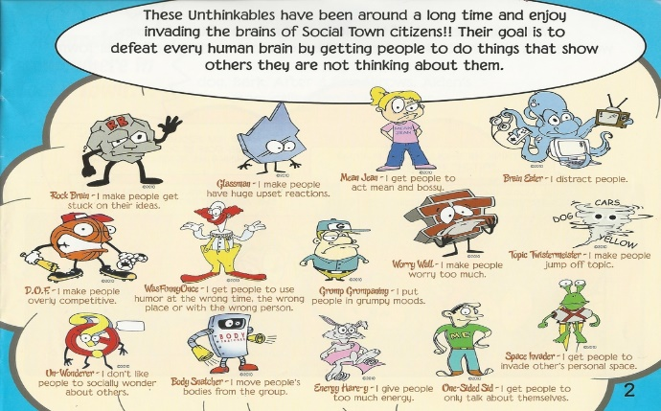  Share with your parent which unthinkable invades your brain most often and which strategies we need to defeat them.  Lessons to review: https://www.youtube.com/watch?v=FrFh8FzmAOw&t=198s  Book on Anxiety and Fear:  The Bravest Worrier (Local Author) one of my favorite books. https://www.thebravestworrier.com/  Willa Jean, Worry Machine  No Worries Workbook

