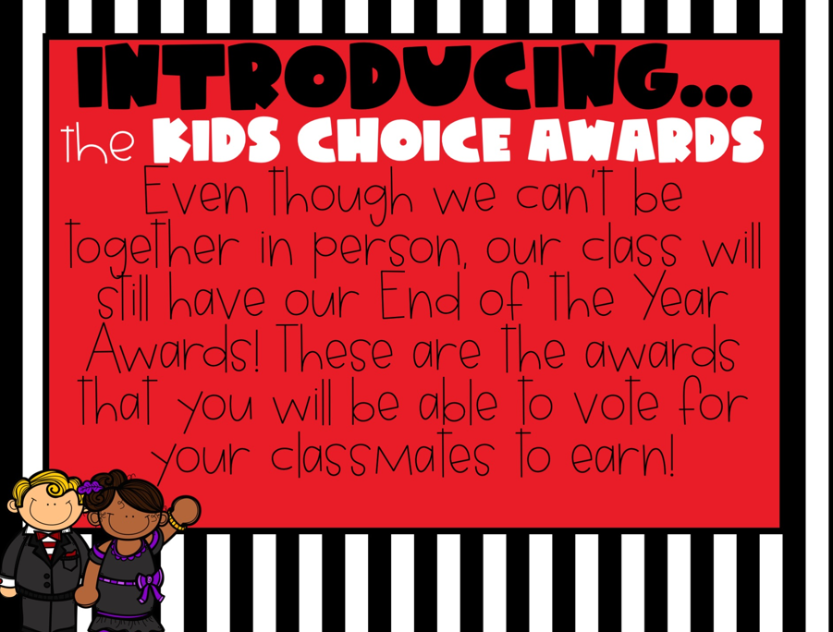

In order to close out the year with a bang, I will be hosting the 1st Annual Kids Choice Awards! This event will take place this Friday, May 15th at 10:00 a.m. on Zoom.

Students, your job is to review the awards that will be presented and to vote which student in the class should earn the award. Please use the list to ensure that you have nominated all students in the class. Votes will be tallied, and awards will be presented on Friday! To ensure every student has the chance to vote, please submit your votes no later than Thursday at 5p.m. Instructions for how to vote are listed below!

P.S. Don’t share your nominations with others, we want to keep it a SURPRISE!
List of Awards
- Sunshine: someone who has been a burst of sunshine in our classroom! They are always happy and smiling!
- Marvelous Mathematician: someone that is amazing at math! They can solve problems in their heads and always win math games!
- Curious George: someone who has a lot of questions! We could always count on them to ask, “What if?” and make us think!
- Amazing Artist: someone that loves to color, paint and draw! We were able to enjoy their drawing and illustrations throughout the year.
- Future Teacher: someone who will make a fabulous teacher one day! Their future class will be so lucky to have this person as their teacher!
- Most Dependable: someone who helps in so many ways! Without this person, a lot of things in our classroom would not get done.
- Superhero: someone that helps make our class great! They are always available to help, no matter what is needed, just like a superhero!
- Everyone’s Friend: someone who is always nice, friendly and gets along well with everyone!
- Best Sense of Humor: someone who always keeps us laughing! They have helped make us laugh and smile all year and we love their jokes!
- Future Author: someone who loves writing! We loved listening to their stories and wouldn’t be surprised if they end up on the Best Seller list one day!
- Always Smiling: someone that has a smile that lights up our classroom! Their smile always makes us feel better and brings us so much happiness!
- Future Principal: someone who is a leader in our classroom! This student is a hard worker, helpful and caring! They will make a great principal one day!
- Best Listener: someone that always has their listening ears on, and they are always ready to learn new things! We can always count on them to be a great listener!
- Future President: someone that might end up living in the White House one day! They are a leader in and out of our classroom and make responsible choices.
- Bookworm: someone that is always in the media center and has their head in a good book!
- Awesome Athlete: someone that is great at all sports and always shows great sportsmanship! They have a blast at recess and love PE!
- Care Bear: someone who is always showing that they care about others. They help us when we are down and help to keep us smiling, no matter what!
- Character Kid: someone who is great to be around and always shows great character traits! They are respectful, responsible, and a role model to others!
- Handy Helper: someone who is always helping in our classroom! From picking up trash, to sharpening pencils, they are always willing to lend a helping hand!
- Computer Whiz: someone that loves technology. Whether it’s being on a computer, or an iPad this student always knows exactly what do!
- Amazing Attendance: someone that had great attendance! They worked hard and always did their best!
- Fact Finder: someone that always wanted to learn more! They ask questions and research new things!
- Nice and Neat: someone who always had a clean and organized space!
- Love of Learning: someone who is always searching for knowledge

Now, Let’s Vote!
Directions: Place the student number next to the award you are nominating them for. Make sure to only vote for each person one time. Cross off their name when you are finished.
***You may: copy and paste your votes, take a picture, or type answers in a word document and share via email, Remind or Office 365. (I am not picky!) ***
Remember: Votes must be placed no later than Thursday @ 5:00 p.m.
Award | Student Number
Sunshine
Marvelous Mathematician
Curious George
Amazing Artist
Future Teacher
Most Dependable
Superhero
Everyone’s Friend
Best Sense of Humor
Future Author
Always Smiling
Future Principal
Best Listener
Future President
Bookworm
Awesome Athlete
Care Bear
Character Kid
Handy Helper
Computer Whiz
Amazing Attendance
Fact Finder
Nice and Neat
Love of Learning

